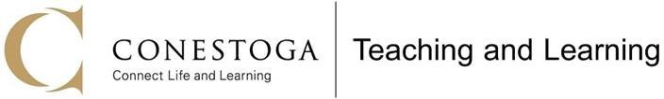

Reflections on my Observation of Teaching

Thank you for participating in the observation process. You have now had a chance to read through the observations, and we want you to reflect prior to our debrief/coaching session. Please note the reflections will be attached to the e-mail sent to your Chair.

Please save this PDF with your name, answer the questions, and return it to your observer within one week.

Name of Observer: Click or tap here to enter text.
Name of Professor: Click or tap here to enter text.
Date of Observation: Click or tap here to enter text.

- Of all the observations shared with you, which one resonated the most and why?
Click or tap here to enter text.

- Did everything go according to plan during the lesson? If you could change anything, what would you have done differently?
Click or tap here to enter text.

- After reflecting on your lesson and reading the observer's comments, two or three strategies/practices you will start implementing in your next classes are as follows:
Click or tap here to enter text.

- How did you know that students were learning (e.g., comprehension checks, formative assessments, chat comments)?
Click or tap here to enter text.

- What are some general teaching topics you’d like to learn more about in courses and workshops from Teaching and Learning?
Click or tap here to enter text.

- In the coaching session, I would like to discuss/learn about the following:
Click or tap here to enter text.

- Was there any wording in the observation you’d like to discuss or have changed prior to this being sent to your Chair?
Click or tap here to enter text.

Website: Faculty Learning Hub Twitter: @TLConestoga
YouTube: Teaching and Learning Conestoga

