Easy Warm-Ups and Bridge-In Activities for our Zoom synchronous classes

Nasreen Sultana, PhD
As 2021 continues, virtual synchronous classes have become a reality now. Online classes have chances to be less energetic as too many screens are off or simply because participants may feel Zoom fatigue. Using icebreakers can offer a good start of you Zoom classes. The following energizers have been used by many Professors and our teaching and learning consultants at Conestoga College successfully. You may want to try them irrespective of what platform you are using.

Power of music
When students are joining the classes and while they wait for the class to start, you may want to play music. Now Zoom has the option (Figure 1) in advanced setting which enables you only to share music while you may want to mute yourself as a host. If you are not comfortable or unsure about the lyrics of the songs, you may just play instrumentals or play CBC radio. Music will create a positive beginning of your class.
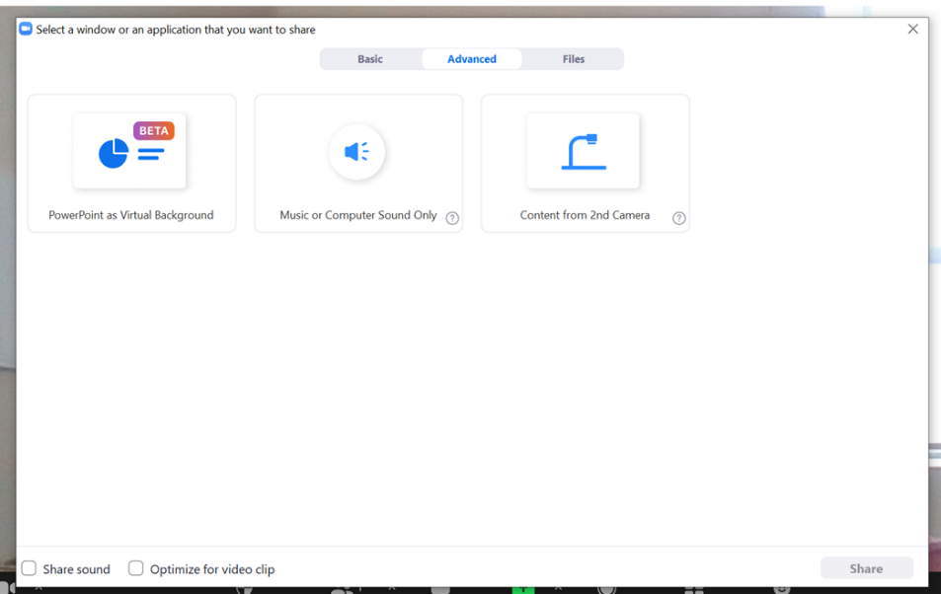
Figure 1 Screenshot of sharing music, with advance setting

A morning fun question
In the first five minutes of the class, you may screen share Figure 2 and ask a simple question to the class, “what combination of breakfast do you like for your breakfast?” Please post your response in the chatbox. Students usually like to find a combination for themselves. You may want to start with yourself describing your favourite breakfast combination, for example, my combination is D1D. You can have a good start of the day. This is a good warm up activity especially for a morning class.
Figure 2 image of toast and coffee (from http://www.planetfood.co.uk/)

Who said this?
Have your students send you a couple of statements about themselves to you before you start the classroom. You can put all the statements on a question wheel picker and spin the wheel. When a statement is picked up by the wheel, the students will guess who the person behind the statement is. Alternatively, you can use simply put the statements on the PPT slides and share the screen.

Review previous lesson/ topic
You can ask interesting questions about your previous class or topic and put them on a PPT slide and use another name picker wheel to pick student’s name to answer them. Some of the useful questions include, ‘our first quiz is on 22 Feb: True or False’, ‘ask me a question about previous class’, ‘where can you find support for APA’, ‘what is the deadline for assignment 3?’ or any thing related to your course content. If you use the name picker, students will not feel picked up by you. Alternatively, you simply can use poll feature on Zoom. However, using name/question picker will make the class more participatory.

Find a GIF
This works as a small breakout/ team activity. Send students to breakout rooms with a prompt to find a GIF which sums up the expression. Your prompts can be something like this, ‘how I feel on a Zoom class’, ‘how I feel in the morning’, ‘how I feel when I take an examination’ or anything else you like. Once the groups are back to the main session, ask them to screen share. If you have a small group, this task can be done individually too.

Annotate your day
While students are joining and waiting for the class to start, you can share the Zoom whiteboard or a blank PPT slide. You can write simple instructions on the board, such as, ‘describe your last week’, ‘feeling about the weather’, ‘something you want to do when COVID19 is over’ etc.

Cloud your day
The above-mentioned activity can be done by using a word cloud generator too. You can use Mentimeter or answer garden to generate a word cloud.

