Teaching & Learning Spotlight: Breakout Rooms + Shared Whiteboards & Docs
January 19, 20, and 21

Why Use Breakout Rooms?
- Breakout rooms allow participants to join smaller, focused discussion groups during a meeting or class. They are a helpful tool to inspire peer interaction and facilitate dialogue between participants.
- As the Zoom host, you can have breakout groups explore similar or different tasks & topics. Ultimately, breakout spaces support group activities during a lesson.
- Zoom breakout rooms can be created in a lesson or before a lesson (pre-assign) only by the host. For basic information about breakout room set up and settings, view How to Use Breakout Rooms in Zoom and the IT Conestoga page
- Note that breakout rooms are a new feature of MS Teams as well

Options for Creating Breakout Rooms (In Meeting)
- Assign automatically | - Quick and efficient option for informal tasks and practice activities  - Quantity of participants per room will automatically adjust to the number of rooms selected  - Manual adjustments can be made before rooms are opened | 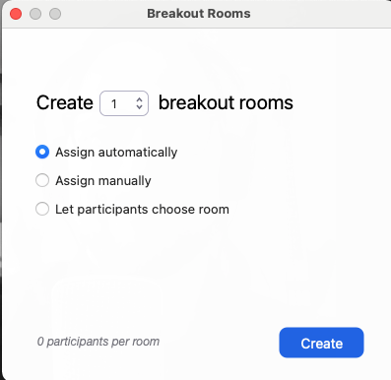
- Assign manually | - Takes more time during the meeting, but enables the host to customize who goes where  - Allows for any number of participants per room
- Let participants choose room | - Available in version 5.3.0 or later  - Gives agency/autonomy to learners  - Can be time consuming if participants are distracted or slow to make selections

Option for Creating Breakout Rooms (Pre-Meeting)
- When scheduling a meeting via Zoom web client, check off “Breakout Room pre-assign” under Meeting options:
- Then build your breakout rooms and organize participants via their Conestoga emails
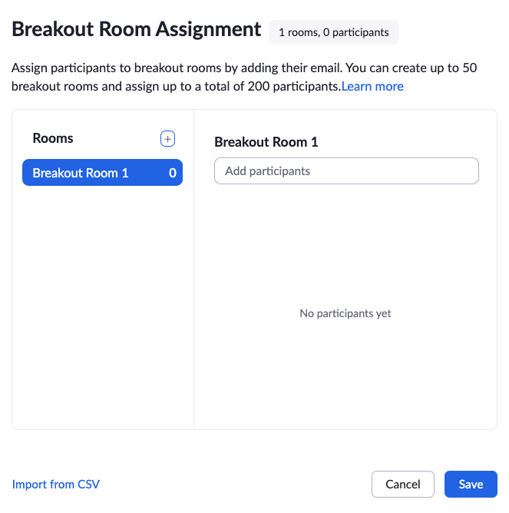

- For a more detailed demonstration of this process, including the option to organize rooms from a pre-created spreadsheet, check out this video: Pre-Assign Breakout Rooms in Zoom
- If you choose to pre-assign breakout rooms, it may be preferential to enable the requirement that students join as “authenticated users.” If they arrive as “guests,” they will not be put into their specific breakout room.

Sharing Whiteboards and Documents with Breakout Participants
- Zoom Whiteboard:
  - Once a group is inside a breakout room, one participant can select Share Screen>Whiteboard to create a blank space upon which any or all group members can draw, add text, stamp, etc.
  - Then, before the breakout room closes, the person sharing their screen can Save the whiteboard so that it downloads locally to their device. This will allow them to then share the file with others or display it back in the main room. (If the room closes before saving, the whiteboard will not be saved)
  - For a demonstration of this process, check out this video: How to use a whiteboard in a breakout room
  - A Zoom whiteboard shared in the main room cannot be viewed in breakout rooms. If you want to share a whiteboard from the main room to the breakout rooms, consider using MS Whiteboards
- MS Whiteboard
  - An Office 365 app that can be accessed online or downloaded
  - Desktop app has many features, including uploading images on the whiteboard than can be written on
  - Works seamlessly in MS Teams. In Zoom, share a link to a collaborative whiteboard (participants open in a second browser)
  - Note that the downloadable app does not appear to be available for Macs (mobile Apple devices only)
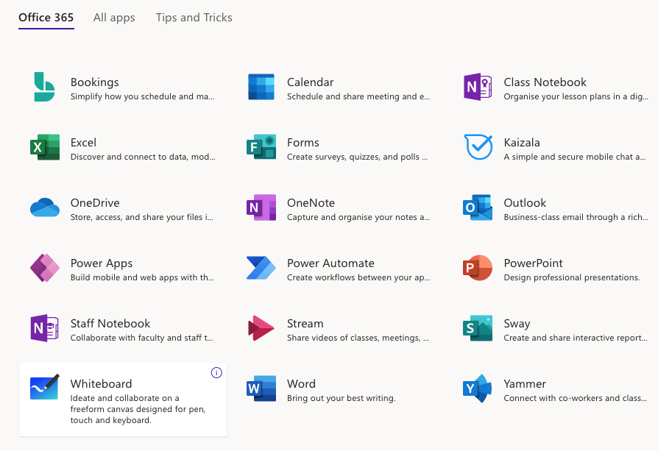
- Collaborative Documents:
  - Collaborative documents enable others to add to and/or co-author. Collaborative documents are a good way to capture breakout discussion or provide questions that students can answer.
  - Students can access shared documents in the main room or in a breakout room. Some students may have difficulty moving between Zoom and collaborative document windows
  - Office 365 collaborative documents are not saved to one’s local device but instead “live in the cloud” using the online version of MS Word, PowerPoint, Excel, etc. They are saved in OneDrive, a folder system for online files
  - In order for a document to become collaborative, a link to it must be shared in the text chat
  - A host can monitor co-authoring without moving into breakout rooms
  - If using the same document for all breakout groups, make it clear where they should author
  - For more information on OneDrive, see OneDrive overview

Basic Breakout Room Management Tips for Hosts
- Prior to “breaking out,” share instructions both verbally and in the chat so that participants understand the activity & the deliverable before starting the group discussion
  - Note: Content added to the public chat will follow participants into their breakout rooms, but content added to a breakout room chat won’t follow them back into the main room
- Repeat instructions and ask for questions before sending people to breakout rooms. Especially if your settings force students into the room, once the rooms open students will be moved there from the main room automatically and won’t be able to ask you any questions
- Timebox the activity: Give time reminders in “broadcast message”, and in the settings set the rooms to an automatic close (you can elect to keep the breakout rooms open if you want
- Remind students that they may “invite host” to join their breakout room if they have questions or problems
- Hosts can also “join” any breakout room to manually check in on students and offer supports

