Orientation to Technology at Conestoga

This document is maintained by the Educational Technology Officer in Teaching and Learning. Suggestions for revisions should be submitted via email directly to the Educational Technology Officer.

Communications Practices
As per the Email, Voicemail and Corporate Calendar Guidelines, your new Conestoga email is the only appropriate method of communication with students and other employees.
Correspondence should be responded to within two business days.

Universal Launchpad
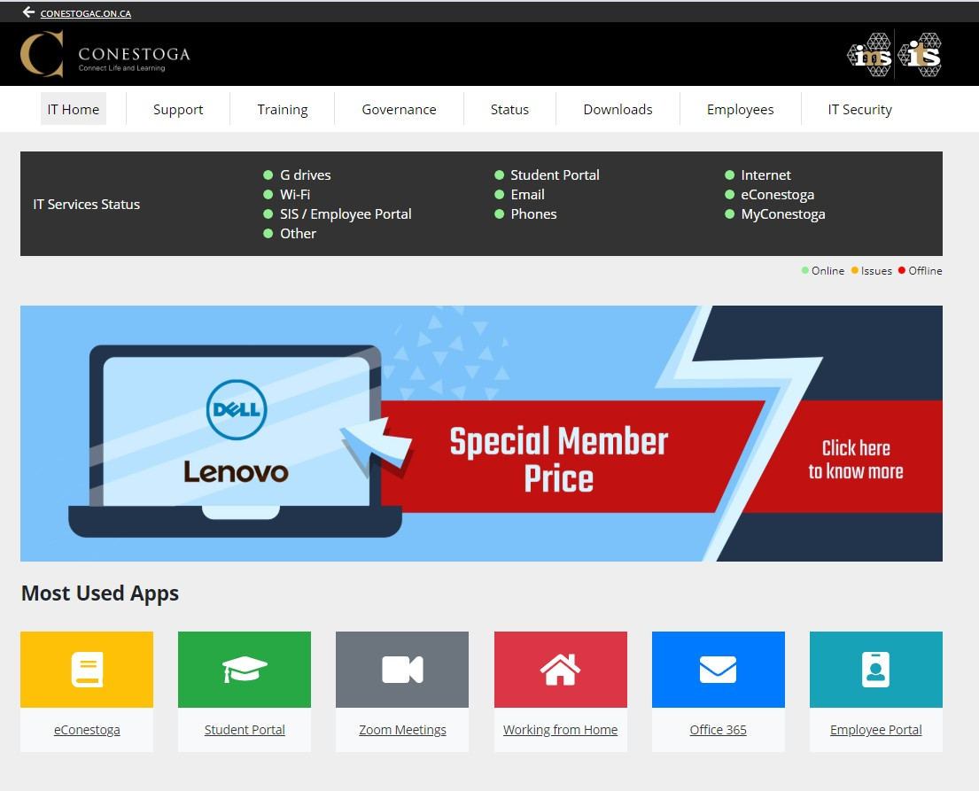
Use the IT Support website as your universal launchpad to college portals and services.

Identification
At Conestoga, we use a few ways to identify our employees. These are:
- An employee number: A seven digit number, usually the same as a Contract Number.

A Condor ID
- An email address

A ONEcard

Condor ID and Email
Your Condor ID and default password will be emailed to the personal email you provided the college during the hiring process. Learn how to find your email in the Employee Portal.
Once you have your Condor ID, discontinue using your contract number to access college services. Use your Condor ID and password to sign in to all services.
Conestoga emails are formed by combining your Condor ID and the @conestogac.on.ca suffix.

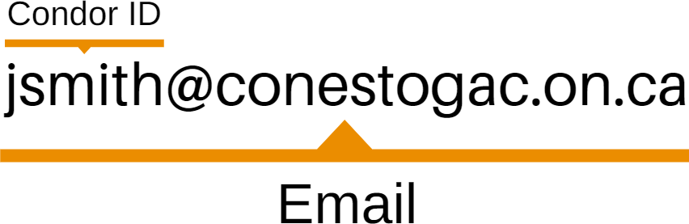

To do
The following are several steps to complete, once you have your Condor ID and email.
- Request your official Conestoga identification (ONEcard) online. Use this to prove employment status, borrow equipment or purchase items on campus.
- Set up your Account Recovery. This will help you recover your email and network account if it becomes locked.
- Access your O365 email through the IT Support website. All communications will now be directed to this address.
- Set your email signature. Learn how to add a signature in Outlook email.

Sample Email Signature
As per the Staff Handbook, emails must have an appropriate signature. Example:
Jane/John Smith, B. Ed., M. Ed., Ph.D.
Communications Professor, School of Language and Communication Studies Conestoga College Institute of Technology and Advanced Learning
299 Doon Valley Drive Kitchener, ON

Office: A2101 (Ext. 1234)
Availability: Monday 10:00 – 12:00, Thursday 11:00 – 1:00 or by video chat by appointment.

Password Changes
Account passwords expire every 90 days. You will receive an email notification a week in advance. Make sure your password meets the secure password criteria.
Voicemail
Learn how to set up your voicemail. Part time employees are not issued voicemail, unless requested.
Suggested Mobile Apps
Download these apps to your iOS or Android devices.

Conestoga Mobile Safety
- Honk Mobile Parking
- Brightspace Pulse (eConestoga)

Microsoft Outlook
- Microsoft OneDrive
Document Storage
Portable USBs or hard drives pose a loss or theft risk. Please avoid using these. If you require one, it should use encryption software, available through the IT Support website.
Use your O365 OneDrive as your personal document storage location. Some departments or programs use either SharePoint or the S: Drive for shared departmental storage.

Suggested Practices
Organize your OneDrive content in alignment with the organization of your eConestoga courses, usually week by week. Learn how to share content with your colleagues, coordinators or Chair, as requested.
Working and Teaching Remotely
Conestoga uses Zoom and Microsoft Teams as remote working and teaching tools. Learn more about each of these services to prepare for the semester.
Zoom is a cloud-based videoconferencing platform which can be used by faculty to deliver course material in a live meeting environment. Zoom has additional features including screen sharing, whiteboard & annotation, breakout rooms, and polling,
Microsoft Teams is the chat and collaboration component of the Microsoft 365 ecosystem, and can be used to host meetings, organize discussions into channels, and share files. Teams features seamless integration with other tools such as OneDrive, OneNote, and numerous other Microsoft and external apps.

The Employee Portal
Portals
The Employee Portal allows access to administrative components of employment, such as:
- Contracts
- Timetables
- Course Outlines
- Attendance lists
- Absence reporting
- Accommodation letters
- Electronic test booking
- Grades entry
Please ensure the privacy or encryption of any information retrieved from the Employee Portal.

The Student Portal
The Student Portal allows registration for internal workshops and professional development
opportunities, such as:
  - The Conestoga Faculty Orientation Program
  - Individual workshops
  - Workshop series, and
  - Yearly conferences
Room numbers are listed in the Employee Portal, once registration has occurred. Workshops listed as “Offsite” are usually virtual workshops. The organizer will reach out with more information.

eConestoga
eConestoga is the college’s learning management system (LMS), which uses the D2L Brightspace platform. It is used to develop, deliver, and manage course materials and optionally administer student assessments such as quizzes and file submissions.
Course Shells
An eConestoga course shell is built automatically for all full-time courses delivered at the College and the system handles all enrollment functions.
A course shell will contain a variety of content and tools, depending on previous deliveries.
You are free to determine which of eConestoga’s capabilities you would like to incorporate, as long as the minimum course standards are met.
The Essential Elements
The Essential Elements are the minimum course standards, and aim to provide students with:
- a Course Information module, which includes the Instructional Plan,
- an Evaluation module, including instructions and rubrics or marking schemes,
- modules with week-by-week information, including all instructional materials, and
- grades posted for each evaluation.
These standards aim to provide consistency for students and faculty in using eConestoga.
The Instructional Plan
The Instructional Plan is the detailed outline for how a course will be delivered. Other institutions may call this a syllabus.
An Instructional Plan ensures:
- evaluations have been distributed in a way that allows for marking and feedback,
- students can anticipate and prepare for the key concepts being delivered each class,
- the date for each evaluation is clearly communicated from the start of the semester. A customized Instructional Plan should be uploaded to each course.
Sandboxes
Every faculty member is provided with a Sandbox course shell within eConestoga. This is a space where you are encouraged to test the platform’s tools and experiment with content before populating your student facing course shells each semester.
Faculty Support
Visit the Faculty Support area in eConestoga to search for instructional plan template, guides, and training videos to support your use of eConestoga.

Classrooms for Hybrid Courses
21st Century Teaching and Learning
Conestoga has made every effort to standardize equipment within classrooms and meeting rooms. Room set up could vary at some locations as new equipment becomes available.
There are three main classroom types: Standard, BYOD, Active Learning and HyFlex. Learn more about each classroom type.
Podiums and Projectors
Each classroom has similar podium controls. Learn how to use the podium controls.
Some classrooms have interactive projectors, which turn your projected screen into a tablet. Learn how to use interactive projectors.
Computers
Conestoga uses Windows 10 computers, with a standardized image. Sign into computers with your Condor ID and password.
To protect your privacy and security by lock your computer before leaving it. Use the keyboard shortcut Windows Key + L to lock a computer.
Visit the Downloads page on the IT Support website to explore additional licensed software available to faculty and students.
Device Use in Learning
The Student Guide states, "Electronic devices may be used for learning or instructional purposes. Professors or technologists may request devices be put away when a safety issue or distraction occurs. Devices used for accommodations are always welcome.”
Review some tips and best practices to support a device friendly classroom. Identify and explain any safety concerns about using devices, particularly if you teach in a workshop.
Virtual Tech Help from the Library
Tech Help and Teach Me Tech Services are now online:
- Book appointments for troubleshooting and tech support from knowledgeable staff;
- Learn about building content, creating awesome online presentations, and more with the
Digital Skills Toolkit;
- Access self-paced online learning through LinkedIn Learning.

Tech Help and Teach Me Tech Services are available to all employees and students and can be accessed online 24/7.

Bring Your Own Device (BYOD) Programs

Many programs at Conestoga require students to bring their own devices. Learn more about supporting a device friendly learning environment.

Check the list of BYOD programs to verify whether a course is in a BYOD program.
eTexts

Many programs at Conestoga are part of the eText program instead of textbooks to improve access to educational materials. eTexts are delivered through eConestoga.

Check the list of eText programs to verify whether a course will use an eText.
Open Education Resources (OERs)

Many programs at Conestoga use Open Educational Resources (OERs) instead of textbooks to improve access and cost of educational materials.

OERs may also supplement course materials. At any time, you can look through OER collections by subject, and use these to supplement your textbook or course materials.
Device Use in Assessments

The Student Guide states that "Unauthorized devices in a testing situation will result in an academic offence and a mark of zero."

Remind students of expectations for academic integrity before delivering a test. Clarify what devices are authorized and the manner in which they will be used.

Before Class
Preparing for your First Remote Class

- Familiarize yourself with Zoom or Teams, depending on your delivery.
- Fill out your Instructional Plan, and post it in your course.
- Consider best practices when teaching remotely.
- Review and adjust any available course materials. Make sure they are fully accessible.
- Make sure all materials are posted in your course.

Setting Up

- Open any tabs or software you will need to present to students.
- Welcome students to your class, prompting them to ensure that their correct name is displayed by Zoom or Teams.
- Use the remote presentations slide deck template to present your materials.

Turn on the projector.
- Open a browser.
- Go into your eConestoga course.
- Download or pre-load the links to instructional materials for your class.
- Expand what you’re presenting to full screen. Zoom in if needed.

Orienting Students to your Course

Many of your students may be brand new. You may need to use part of the first class to:

Explain how they should communicate and collaborate with you and with each other
(by email or eConestoga course mail, and the OneDrive),

Co-create expectations about appropriate behaviours and device use,
- Download the Brightspace Pulse app to students’ mobile devices
- Tour the eConestoga course, finding the Course Outline and Instructional Plan.

Before Class
Preparing for your First Face to Face Class

- Familiarize yourself with your classroom setup and the podium controls.
- Fill out your Instructional Plan, and post it in your course.
- Consider best practices when presenting in a classroom or lab.
- Review and adjust any available course materials. Make sure they are fully accessible.
- Make sure all materials are posted in your course.

Setting Up

- Distribute name tents, asking students to fill in their name and preferred pronouns.
- Sign in to the podium’s PC or connect your laptop or tablet.

Turn on the projector.
- Open a browser.
- Go into your eConestoga course.
- Download or pre-load the links to instructional materials for your class.
- Expand what you’re presenting to full screen. Zoom in if needed.

Orienting Students to your Course

Many of your students may be brand new. You may need to use part of the first class to:

Explain how they should communicate and collaborate with you and with each other
(by email or eConestoga course mail, and the OneDrive),

Co-create expectations about appropriate behaviours and device use,
- Download the Brightspace Pulse app to students’ mobile devices
- Tour the eConestoga course, finding the Course Outline and Instructional Plan.

Bring in Active Learning Strategies
Once You’re Ready
Once you are comfortable, try incorporating some of these strategies in your teaching.

Whole Group Activities | Small Group Activities | Individual Activities
Brainstorming Discussions Post-It Parade Dotmocracy Snowball Quescussions  Jigsaw | Think, Pair, Share Concept Mapping Inquiry Based Learning Case Studies  Think Alouds Respond, React, Reply  Social Annotation of Texts | Individual Reflections Journals or Discussion Posts Post It Parade  KWL Charts  One Minute Papers

Visit the Faculty Learning Hub
The Faculty Learning Hub is Conestoga’s source for information about effective and tech- enabled teaching practice. Visit the Faculty Learning Hub to develop your practice, or explore tech to use in your teaching. Read about Faculty Stories, ask questions, and share in the learning
Faculty often experiment with fun and educational technologies to support and engage their learners.
Check the Tech heading on Teaching and Learning's Faculty Learning Hub to find out about new recommended apps.

IT Services
Technical Support Contacts
The IT Service Desk provides support to all employees and students on:
- Condor IDs, passwords, and account recovery,
- classroom and lab hardware,
- software downloads, and
- college issued devices.
Visit the IT Support website or email itsdesk@conestogac.on.ca, for 24/7 email support.

The Online Learning Centre (OLC)
The Online Learning Centre offers support for eConestoga, including:
- building content,
- the Essential Elements of a course,
- discussions, assignments and rubrics,
- quizzes and grades.
Visit the Faculty Support site or email econestoga@conestogac.on.ca for help. Upcoming trainings are posted in the Announcements area within eConestoga.

Teaching and Learning
The Educational Technology Officer provides support to Conestoga faculty on:
- creating accessible and engaging course materials,
- teaching within remote, HyFlex, BYOD, eText or OER programs,
- tech-enabled teaching and learning experiences.
Visit the Faculty Learning Hub or email teachingandlearning@conestogac.on.ca for help.

The Library
Library services and resources are available online for all Conestoga employees and students. Access an extensive collection including eBooks, streamed videos, articles and online help.
Use your Library Pin, the last 4 digits of your Conestoga employee number or ID to access from home.

Supports provided by the Library include:
- Academic Integrity
- Assistive Technology & Alternate Formats
- Course Readings Support
- Copyright Guidance
- Instructional Supports
- Tech Help Consultations & Digital Skills Modules
- Writing Services
Visit the Library’s website, try their virtual chat/text service, askON, visit their For Faculty page, or email lrcinfo@conestogac.on.ca for help.

The Bookstore
The Bookstore provides support for all Conestoga employees and students on:
- eText programs,
- digital access codes for publisher resources.
Visit the Bookstore’s website or email bookstore@conestogac.on.ca for help.

